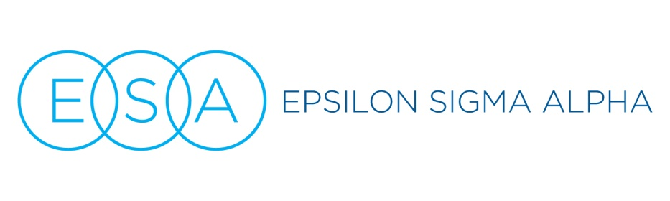

Podium Talking points: Literacy Project

- About (ADD INFO ABOUT THE ORGANIZATION BENEFITING FROM YOUR PROJECT TODAY… HEADSTART, BOYS AND GIRLS CLUB, ADULT LEARNERS LIBRARY, IMAGINATION LIBRARY, ETC, ADD SOME TALKING POINTS FROM THEIR WEBSITE OR LET THEIR REPRESENTATIVE SAY A FEW WORDS)
- We are ALL volunteers. We belong to Epsilon Sigma Alpha because we believe we have the power together to change the world, and because it’s FUN! In addition to supporting literacy projects, we also support St. Jude Children’s Research Hospital, Easter Seals Camp Hope, victims of domestic violence, military members/veterans/families, scholarships through our Foundation and scores of other local worthy causes. Our network of chapters is multi-national AND multi-generational, from college students to active seniors, and we are always keeping an eye out for others who might like to join ESA, spend time with good-hearted people, and make a difference with us. We’re so grateful you’re here today to help us bring the power of reading to deserving people through (NAME THE CAUSE) and invite you to speak with one of the ESA members here today if you’d like to know more about joining ESA and helping with other great projects like this one. (tell them where in the room they can get more information)

